SIMATS ENGINEERING
ASSESSMENT TOOL 1

COURSE NAME: Artificial Intelligence COURSE CODE: CSA17

COURSE OUTCOME COVERED

CO2: Experiment search and game-solving techniques such as Greedy Search, A*, CSP, Minimax, and Alpha-Beta pruning with heuristic functions for solving complex AI problems efficiently. (BL3)

Assessment Tool Weightage: 35%

Duration: 1 Hour
QUESTIONS: 5 Total Marks:50

Annexure A

Scenario Based Assignment

Code of Conduct:

I S.K. Deepa Arathi / 192571020 (Name / Reg No) certify that this submission is my original work and that I have adhered to the guidelines specified for this assessment.
I understand that any violation of academic integrity rules will result in disciplinary action.

Signature of the student:

Annexure A

Scenario Based Assignment

1. Scenario : A government deploys AI-powered drones to deliver emergency medicines in a flood-affected region. The environment is highly dynamic—roads may suddenly become inaccessible, and weather conditions affect travel cost. The drone has access to: A heuristic estimate (straight-line distance), Partial real-time updates about blocked paths and Variable movement costs depending on terrain and weather. However, due to urgency, the drone must quickly decide routes with minimum delay and risk.
Tasks:
- Explain how Greedy Best-First Search would behave in this scenario and discuss its strengths and weaknesses under uncertainty
- Explain how A* would handle the same situation, including how it balances cost and heuristic
- Analyze the impact of heuristic accuracy on both algorithms
- Discuss how dynamic changes (blocked paths) affect search performance
- Recommend the most suitable algorithm and justify your decision considering real-time constraints, optimality, and safety
2. Scenario: A smart city implements an AI system to optimize traffic signal timings across hundreds of intersections. The objective is to minimize Total waiting time, Fuel consumption and Traffic congestion. The system must continuously adjust signals based on traffic flow. However the search space is extremely large, traffic patterns change dynamically and the system may get stuck in locally optimal solutions
Tasks. Formulate this as an optimization problem and explain why traditional search is inefficient
- Explain how Hill Climbing would work in this scenario and identify its limitations
- Discuss issues like local maxima, plateaus, and ridges with real-world interpretation
- Explain how Simulated Annealing or Genetic Algorithms can overcome these limitations
- Recommend the best approach and justify your choice based on scalability and adaptability
3. Scenario: An autonomous rover is deployed on Mars to explore unknown terrain. It must: navigate safely to collect samples, avoid hazards (craters, rocks), operate with limited sensing capability and make decisions without a complete map. The rover updates its knowledge as it explores, making this a real-time decision-making problem.
Tasks:
- Explain why this problem requires an online search agent instead of offline search
- Analyze the challenges of partial observability and dynamic environments
- Describe how the rover builds and updates its internal model
- Compare online search with uninformed and informed search strategies
- Justify the most suitable approach considering uncertainty, adaptability, and safety
4. Scenario: A university is designing an AI system to automatically generate exam timetables. The system must satisfy multiple constraints: No student should have overlapping exams, Limited number of exam halls, Certain subjects must be scheduled before others, Faculty availability constraints, Special accommodations for some students, The complexity increases as the number of courses and students grows.
Tasks :
Formulate the problem as a Constraint Satisfaction Problem (CSP)
- Clearly define variables, domains, and constraints with explanation
- Explain how backtracking search works in this scenario
- Discuss how constraint propagation (e.g., forward checking) improves efficiency
- Analyze real-world challenges and justify the best strategy for scalability

5. Scenario: Strategic Game AI for Real-Time Decision Making (Minimax & Alpha-Beta Pruning) A gaming company is developing an AI opponent for a real-time strategy game. The AI must complete against human players, Make decisions within strict time limits, Evaluate complex game states with multiple possible moves, The decision tree is extremely large, making computation expensive.
Tasks:
- Explain how the Minimax algorithm models this problem
- Analyze the computational challenges of large game trees
- Explain how Alpha-Beta pruning improves efficiency with detailed reasoning
- Design an evaluation function and justify the factors considered
- Recommend a strategy for balancing optimality and real-time performance

RUBRICS FOR CALCULATION

Criteria | Weightage (%) | Level 4 (Exemplary) | Level 3 (Proficient) | Level 2 (Developing) | Level 1 (Beginning)
Understanding of Scenario | 20% | Demonstrates clear and complete understanding of the scenario and context | Shows good understanding with minor gaps | Partial understanding; misses key aspects | Misinterprets or fails to understand the scenario
Identification of Key Issues | 20% | Accurately identifies all relevant issues and factors involved | Identifies most key issues with minor omissions | Identifies limited issues; some irrelevant points | Unable to identify key issues
Application of Concepts | 25% | Applies appropriate concepts effectively to address the scenario | Applies concepts with minor errors | Limited or partially correct application | Unable to apply relevant concepts
Decision Making | 20% | Makes well-reasoned, logical decisions with strong rationale | Makes reasonable decisions with some justification | Makes weak decisions with limited justification | No clear decisions made or rationale provided
Clarity of Response | 15% | Response is clear, structured, and logically presented | Generally clear with minor issues | Somewhat unclear or poorly structured | Disorganized and difficult to understand

Question 1: Drone Delivery in a Flood-Affected Region (Greedy Best-First Search and A*)
1.1 Understanding the Scenario
In this scenario a government uses drones to carry emergency medicines into an area hit by floods. The drone has to travel from a base station to a delivery point, but the situation on the ground keeps changing. Roads and landing spots can get blocked suddenly, the weather changes how much energy and time a move costs, and the drone only gets partial real-time information about which paths are closed. The only thing it knows for certain is the straight-line distance to the destination, which is a heuristic estimate. Because medicines are time-critical, the drone must choose a route quickly, and the route must also be safe because a crash means the medicine is lost.
This can be written as a search problem. A state is a location of the drone on the map (for example a cell of a grid). The actions are moves to neighbouring locations. The step cost is not constant, because a move through a stormy or difficult area costs more than a move through a clear area. The goal test is reaching the delivery point. The heuristic h(n) is the straight-line (Euclidean) distance from location n to the goal. Since the shortest possible path between two points is a straight line, this heuristic never overestimates the real cost, so it is admissible when the minimum step cost is 1.
To understand the behaviour of the two algorithms properly, I made a small model of the situation. It is a 10 x 10 map in which every cell has a movement cost of 1, 2 or 3 (clear air, moderate wind and heavy rain or rough terrain respectively), and some cells are completely blocked (flooded or collapsed areas). The drone starts at the top-left cell S and has to reach the bottom-right cell G. I ran both algorithms on this map, and the numbers quoted in this answer come from that run.
1.2 Behaviour of Greedy Best-First Search
Greedy Best-First Search always expands the node that looks closest to the goal, which means it orders its frontier only by f(n) = h(n). It completely ignores the cost already spent to reach a node, which is g(n). In the drone problem this means the drone keeps flying towards the delivery point in the most direct way and only turns away when an obstacle forces it to.
In my experiment the greedy search expanded only 21 nodes and found a route very quickly. This is the main reason it looks attractive in an emergency. However, the route it returned had a total cost of 26, while the best possible route costs 20. It was cheaper to compute but more expensive to fly, because the algorithm happily went through heavy-weather cells just because they were pointing towards the goal.
Strengths under uncertainty
- It is very fast and uses little memory, since it expands only a small part of the map. This suits a drone with limited onboard computing power.
- It needs only the straight-line distance, which is always available even when the real-time information is incomplete.
- When the map changes it can restart from the current position at almost no extra cost, because its search effort is small.
Weaknesses under uncertainty
- It is not optimal. It can choose a path that looks short but passes through expensive or dangerous regions, which is a real problem when weather changes the cost.
- It is not complete in a graph with blocked paths unless repeated states are tracked. It may walk into a dead end (a pocket surrounded by flooded cells), because the dead end is closer to the goal in straight-line distance.
- It has no idea of the risk it has already accumulated, so it cannot compare a short risky path with a longer safe one.
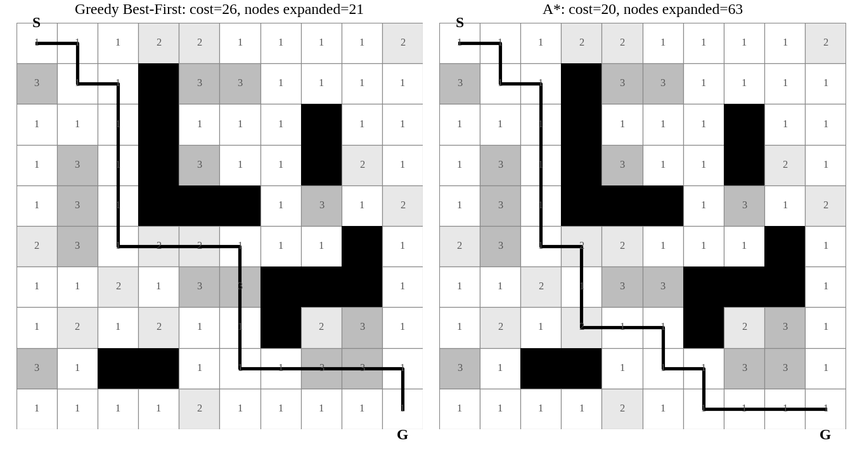
Figure 1.1: Result of Greedy Best-First Search and A* on the same 10 x 10 flood map (black = blocked, grey = costlier cells)
1.3 Behaviour of A* Search
A* orders the frontier using f(n) = g(n) + h(n). Here g(n) is the actual cost of the path travelled from the base to node n, including the extra cost of bad weather and difficult terrain, and h(n) is the straight-line estimate of the remaining distance. The two parts balance each other. The g(n) part pulls the search away from expensive routes already taken, and the h(n) part pushes it in the direction of the goal. If only g(n) were used the search would spread in all directions like uniform-cost search, and if only h(n) were used it would become greedy search.
Because the straight-line distance is admissible (it never overestimates), A* is guaranteed to return the cheapest route. On the model map A* returned a route of cost 20, which is 6 units cheaper than the greedy route. The price of this was more effort, as it expanded 63 nodes compared with 21 for the greedy search. In a real deployment this means A* spends a little more computation to avoid a flight through storm cells, which is usually a good trade for a drone, since energy and risk are the most limited resources.
Feature | Greedy Best-First | A*
Evaluation function | f(n) = h(n) | f(n) = g(n) + h(n)
Uses travelled cost g(n) | No | Yes
Optimal path | Not guaranteed | Guaranteed if h is admissible
Completeness | Not guaranteed on graphs without repeat checking | Complete
Nodes expanded in my test | 21 | 63
Route cost in my test | 26 | 20
Memory | Low | Higher

Table 1.1: Comparison of the two algorithms on the drone problem
1.4 Impact of Heuristic Accuracy
The quality of the heuristic decides how well both algorithms behave. For greedy search a good heuristic is the only source of guidance, so if the heuristic is misleading the search goes the wrong way with no way of correcting itself. In the flood area the straight-line distance is misleading whenever a river or a flooded stretch lies between the drone and the goal, since the real path has to go around it. The greedy search then moves towards the water and gets trapped.
For A* an accurate heuristic means fewer nodes are expanded, because the search focuses on the narrow band of nodes that really lie on the best path. A weak heuristic (for example h = 0) makes A* behave like uniform-cost search, which is still optimal but explores much more of the map. If the heuristic overestimates the true cost it is no longer admissible and A* may return a non-optimal route. To see this, I multiplied the heuristic by a weight w and noted the results.
Weight w | Nodes expanded | Route cost | Remark
0 | 82 | 20 | Same as uniform-cost search
0.5 | 80 | 20 | Weak heuristic
1 | 63 | 20 | Normal A*
1.5 | 34 | 20 | Heuristic stronger
2 | 26 | 20 | Still optimal here
3 | 23 | 22 | Cost starts to rise
5 | 21 | 26 | Almost greedy, cost worse

Table 1.2: Effect of scaling the heuristic on A* (same map as Figure 1.1)
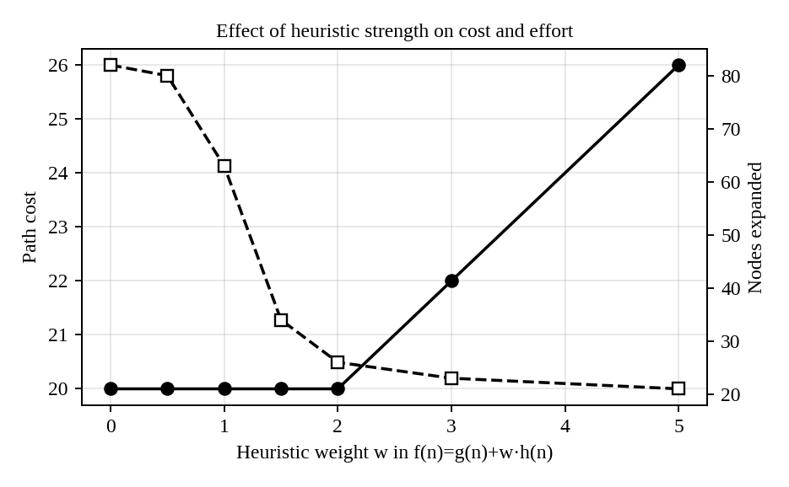
Figure 1.2: Higher heuristic weight reduces the work but eventually increases the route cost
The table shows the trade-off clearly. When the heuristic is trusted more, the number of expanded nodes falls from 82 to 21, but once it is trusted too much (w = 5) the route cost climbs from 20 to 26, which means the algorithm is drifting towards greedy behaviour. For a medicine drone the safe choice is to keep the heuristic admissible so that the route is never worse than the optimum, and to improve its accuracy by adding known information, for example by adding a penalty for regions where heavy rain is forecast.
1.5 Effect of Dynamic Changes such as Blocked Paths
In a flood, new paths can be closed after the drone has already started. Both algorithms plan on the map they have at that moment, so a newly blocked cell can make the whole plan invalid. The drone then has to replan from where it currently is.
I tested this by blocking the cell at row 6, column 3 (which lay in the middle of the planned route) after the drone had completed half of its flight, and then re-ran both algorithms from the drone's current position. A* replanned with 27 node expansions and obtained a remaining route cost of 14. Greedy replanned with 13 expansions and a remaining cost of 18. So greedy is quicker to recover, but it again gives a more expensive remaining path, and in a tighter map it could walk straight into the next trap.
- Search time: every replanning costs time. Greedy reacts faster, A* reacts slower but more reliably.
- Stale plans: a plan made earlier may pass through a cell that is now closed, so the drone must check the next cell before moving into it.
- Partial updates: since only part of the map is updated, the drone should treat the unknown regions as normal cells and correct the plan when new information arrives.
- Better alternatives: incremental versions such as D* Lite or LPA* reuse the previous search result and only repair the affected part, which saves much of the replanning time.
1.6 Recommendation
Considering all points together, my recommendation is to use A\* search with an admissible heuristic, combined with replanning whenever new blockage information arrives (in practice D* Lite, which is the dynamic version of A*). The reasons are given below.
Criterion | Greedy Best-First | A* | Better choice
Real-time speed | Very fast | Slightly slower | Greedy
Optimality of route | Not guaranteed | Guaranteed | A*
Safety (avoids bad weather cells) | Poor, ignores cost | Good, uses g(n) | A*
Handling of dead ends | Can get trapped | Backs out through cost | A*
Recovery after blocked path | Fast but poor quality | Moderate, good quality | A*

Table 1.3: Final comparison for the drone scenario
Greedy search is attractive only because it is fast, but in this application speed alone is not enough. A wrong route costs battery, may expose the drone to storm, and may fail to deliver the medicine. The extra computation of A* is small on modern drone processors and can be controlled by limiting the search area or using a slightly weighted heuristic (w around 1.5 to 2 in my test gave nearly the same cost with much less effort). Greedy search can still be useful as a quick first guess while A* computes the final route. Therefore A* gives the best balance of real-time performance, optimality and safety.
Question 2: Traffic Signal Optimisation in a Smart City (Hill Climbing, Simulated Annealing and Genetic Algorithms)
2.1 Formulating the Problem as an Optimisation Problem
The smart city wants to set the timing of the signals at hundreds of intersections so that vehicles lose as little time as possible. This is not a problem of finding a path to a goal, because there is no single goal state. It is a problem of finding the best configuration, so it is an optimisation problem and it can be formulated in the following way.
Component | Definition for the traffic problem
State (decision variables) | A complete set of signal settings: for each intersection i, the green time for every phase, the cycle length, and the offset from neighbouring signals
Search space | All possible combinations of these values over all intersections
Objective function | Minimise F = w1 x (total waiting time) + w2 x (fuel consumption) + w3 x (congestion index)
Constraints | Minimum green time for pedestrians, maximum cycle length, emergency vehicle priority, no conflicting greens
Neighbour (move) | Change one value slightly, for example add 3 seconds of green to one phase or shift one offset
Evaluation | Run a traffic simulation or use live sensor data to compute F for a state

Table 2.1: Optimisation formulation of the traffic signal problem
The weights w1, w2 and w3 express how important each of the three goals is. Waiting time, fuel and congestion are related to each other, because less waiting also means less idling and therefore less fuel, but they are not identical, so combining them into one weighted score F lets the algorithms compare two configurations easily.
Why traditional search is inefficient
Suppose there are 300 intersections and each one has only 10 sensible timing settings. The number of full configurations is 10 raised to the power 300, which is more than the number of atoms in the universe. Traditional searches such as BFS, DFS, uniform-cost search or even A* try to build a path from an initial state to a goal state and keep a frontier of partial solutions in memory. Here there is no goal test to stop at, the frontier would grow without limit, and the cost of evaluating just one state (by simulating traffic) is already high. In addition, the traffic pattern changes every few minutes (morning rush hour, rain, an accident), so a solution that took hours to find is out of date before it is used. Therefore we need local search methods, which keep only the current state, use very little memory, and can give a reasonably good answer at any moment.
2.2 Working of Hill Climbing and its Limitations
Hill climbing starts from some initial setting, for example the timings that are currently used. At each step it generates the neighbouring settings (a small change to one signal), evaluates them, and moves to the neighbour that improves the objective the most. The process continues until no neighbour is better, at which point it stops. In the traffic problem this is like an engineer who adjusts one signal at a time and keeps the adjustment only if the total waiting time in the city goes down.
- Advantages: very simple, needs almost no memory, and improves the current timing quickly, so it is good for small corrections while the system is running.
- Limitations: it only looks at immediate neighbours, never accepts a worse move, and therefore can stop at a solution that is only locally best. The final answer depends strongly on the starting point.
2.3 Local Maxima, Plateaus and Ridges with Real-World Meaning
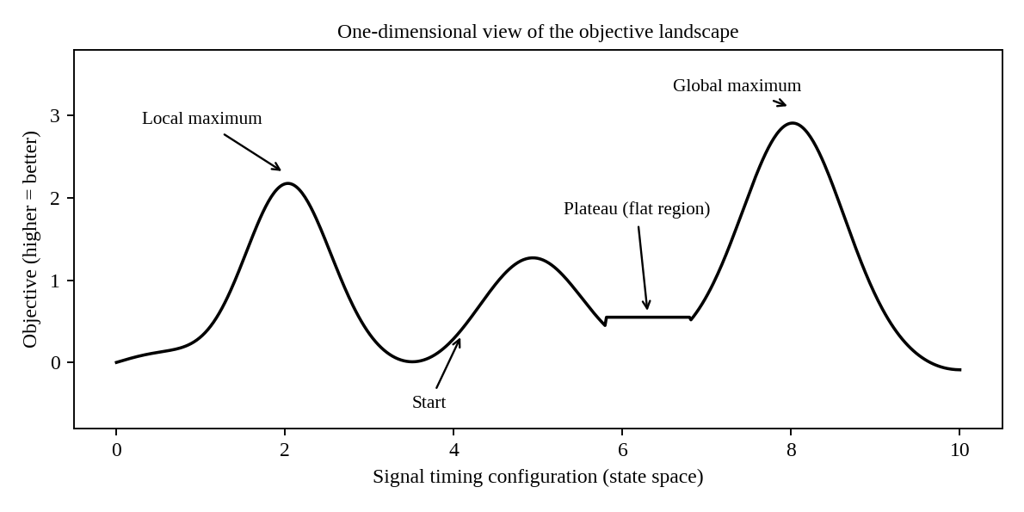
Figure 2.1: Typical landscape faced by hill climbing
Problem | Meaning in the algorithm | Real-world interpretation in traffic control
Local maximum | A state better than all its neighbours but worse than the best state overall | The timing of a few junctions on one road is tuned so well that any single change makes things worse, yet a completely different coordination of the whole corridor would reduce delay much more
Plateau | A flat area where all neighbours have the same value | At night or in light traffic, changing a green time by a few seconds does not change the waiting time measurably, so the algorithm has no direction to follow
Ridge | A narrow path of high values that cannot be climbed by moving along one axis at a time | A "green wave" needs the offsets of several consecutive signals to be changed together. Changing only one signal breaks the wave and makes things worse, although changing all of them together improves it

Table 2.2: Hill climbing difficulties and their meaning
The local maximum problem is the most serious one for this scenario. A city has many roads that interact with each other, so the landscape has a very large number of small peaks. A plain hill climbing run will almost always end at one of them. Plateaus waste time because the algorithm wanders without improvement (or stops if only strictly better moves are allowed), and ridges slow it down since it zig-zags with very small progress.
Some simple remedies exist for hill climbing itself. Random-restart hill climbing runs the algorithm many times from different starting settings and keeps the best result. Stochastic hill climbing picks randomly among the improving moves. Sideways moves allow the search to cross a plateau. These help, but they do not solve the problem fully for a space as large as a whole city.
2.4 How Simulated Annealing and Genetic Algorithms Overcome These Limitations
Simulated Annealing (SA)
Simulated annealing is inspired by the slow cooling of metal. It works like hill climbing, but it sometimes accepts a worse move. If a move changes the objective by ΔE (a worsening), it is accepted with probability e^(−ΔE/T), where T is a "temperature". At the start T is high, so the algorithm accepts many bad moves and explores widely. As T is slowly reduced, it becomes more and more like hill climbing and settles into a good solution. Because bad moves are possible, it can climb out of a local maximum and cross plateaus and ridges.
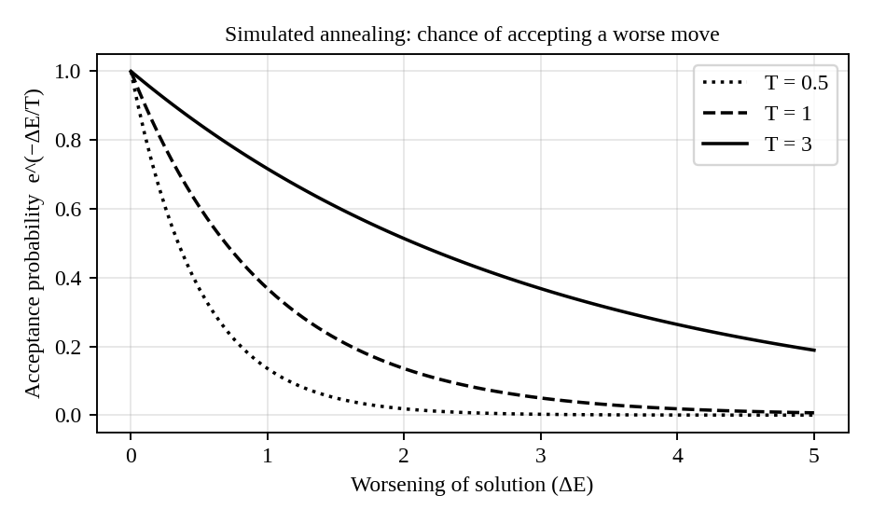
Figure 2.2: Acceptance probability for a worse move at different temperatures
In the traffic system, SA would sometimes accept a timing change that increases waiting slightly (for example giving a side road more green) if that change opens the way to a better coordination later. As the temperature drops the system stabilises. The cooling schedule can also be reset when the traffic pattern changes, so SA can keep adapting during the day.
Genetic Algorithm (GA)
A genetic algorithm keeps a population of complete timing plans (each plan is a "chromosome" made of the signal settings). In every generation it (1) evaluates the fitness of each plan using the objective F, (2) selects the better plans as parents, (3) creates children by crossover, for example taking the timings of the northern part of the city from one parent and the southern part from another, and (4) applies small random mutations. Over many generations the population improves.
GA is attractive for this problem because crossover can combine good partial solutions (a well-tuned corridor from one plan and a well-tuned area from another), which is exactly the thing that is difficult for hill climbing. Since there are many individuals at the same time, the search is spread over many regions of the landscape, which reduces the chance of being trapped in one local maximum. It is also naturally parallel, since each plan can be simulated on a different processor.
To check these claims I tested the three methods on a rugged artificial objective function with many peaks (8 variables, 20 independent runs each). The results are in the table and the figure below. Higher is better.
Method | Average best value | Best run | Worst run
Hill Climbing | 9.51 | 10.58 | 7.5
Simulated Annealing | 10.02 | 11.47 | 9.05
Genetic Algorithm | 10.26 | 11.22 | 9.22

Table 2.3: Result of the small experiment on a multi-peak objective
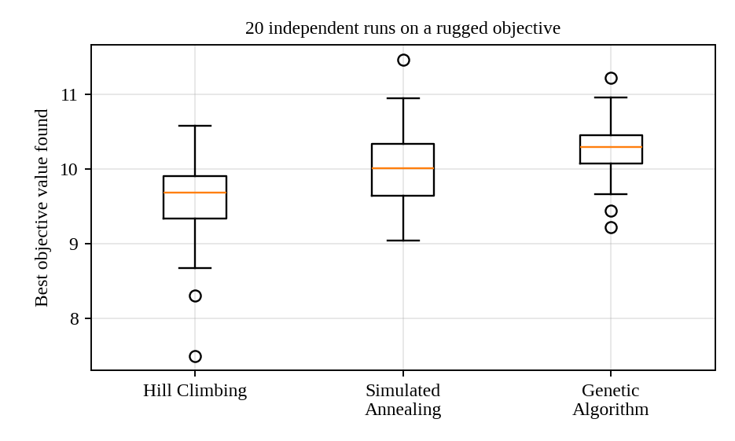
Figure 2.3: Spread of results over 20 runs
Hill climbing gave the lowest average and the worst worst-case, and its answer varied depending on where it started, which is the local maximum problem in practice. Simulated annealing and the genetic algorithm gave better averages and a much better worst case, which means they are more dependable.
2.5 Recommended Approach
Criterion | Hill Climbing | Simulated Annealing | Genetic Algorithm
Avoids local maxima | Poor | Good | Good
Scalability to hundreds of junctions | Good | Good (one solution at a time) | Good, can be run in parallel
Adapts to changing traffic | Quick small fixes | Reheating allows re-adaptation | Population keeps diversity, can restart from old plans
Memory needed | Very low | Very low | Higher (many plans)
Computation per step | Low | Low | High (many simulations)

Table 2.4: Comparison of the three methods
My recommendation is a hybrid approach: use a genetic algorithm (or simulated annealing) for the global planning of timing plans, for example every 15 to 30 minutes or when traffic changes strongly, and then use hill climbing as a fast local fine-tuner between these updates. The genetic algorithm scales well because the plan can be divided region by region and evaluated in parallel, and it keeps a pool of good plans (for rush hour, night, rain) that can be reused when the pattern returns, which gives adaptability. Simulated annealing is a good lighter alternative if the computing budget is small. Hill climbing alone is not recommended, because its results depend on luck and it gets stuck in local maxima.
Question 3: Autonomous Mars Rover (Online Search Agent)
3.1 Why an Online Search Agent is Needed
There are two basic ways in which an agent can search. In offline search the agent computes a complete plan first, using a full model of the world, and then carries the plan out without looking at the world again. In online search the agent computes a little, takes an action, observes what happened, and then decides the next action. It interleaves planning and acting.
The Mars rover cannot use offline search because it does not have a map of the terrain. It lands in an unknown area and can only see a small region around it using its cameras and sensors. A complete plan cannot be made without knowing where the craters and rocks are. Even if an orbital image is available, it will not show small rocks or loose sand. The communication delay between Earth and Mars (several minutes in one direction) makes it impossible to control the rover live from Earth, so the rover must make decisions by itself. And a mistake is very costly, because a damaged rover cannot be repaired. For these reasons the rover must explore and decide step by step, which is exactly what an online search agent does.
Point | Offline search | Online search
Knowledge of environment | Complete map needed in advance | Unknown, discovered while moving
Planning and acting | Plan first, act later | Plan and act alternately
Handling of surprises | Poor, plan must be rebuilt | Natural, each step uses new observations
Typical use | Route finding on a known road map | Robots in unknown places such as Mars

Table 3.1: Offline and online search
3.2 Challenges of Partial Observability and Dynamic Environments
Partial observability
- The rover sees only a few metres around it, so it does not know whether the cell in front of it leads to open ground or a dead end.
- Sensors are noisy. A shadow may be mistaken for a crater, or a smooth rock for flat ground, so the rover has to deal with uncertainty in what it perceives.
- The same observation can come from different real situations, so the agent must keep a belief about the possible situations.
- It cannot be sure that it has actually reached its position, since wheel slip on sand makes dead reckoning inaccurate.
Dynamic environment
- Dust storms reduce visibility and solar power, so the cost of moving changes with time.
- Loose soil can shift and rocks can roll, so a path that was safe earlier may not be safe later.
- Energy, time and communication windows are limited, so the plan must account for resources that keep changing.
- Irreversible actions are dangerous. Driving into a crater cannot be undone, so the agent must avoid the exploration of unsafe states (a safely explorable space is assumed).
3.3 How the Rover Builds and Updates its Internal Model
The rover keeps an internal model of the world, which is basically a map that is initially almost empty. Each cell can be marked as unknown, free, hazard or visited. The model is built and updated by repeating a sense–update–plan–act cycle.
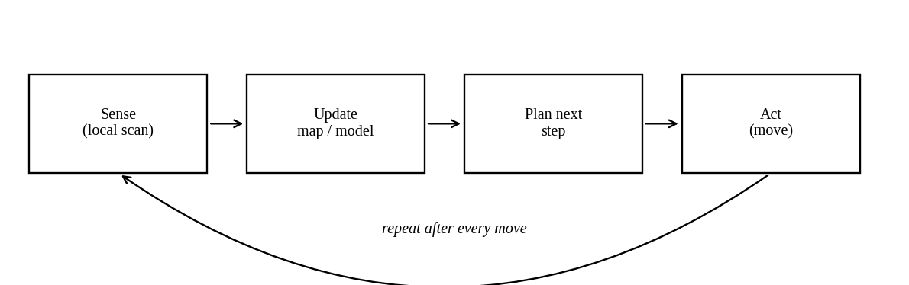
Figure 3.1: Sense–update–plan–act cycle of the online agent
- Sense: the cameras, lidar and wheel sensors give information about the neighbouring cells, and whether the last move succeeded.
- Update the model: the new cells are written into the map (free or hazard), the position estimate is corrected, and the cost of the actions that were just taken is recorded. A table such as result[state, action] stores where an action led, so the agent learns the effect of its own actions. The cells already visited are also stored to prevent endless loops.
- Plan: using the current map, the agent decides the next move. Unknown cells are assumed free (optimistic) or handled with a safety margin, depending on how careful the rover must be.
- Act: it performs one move (or a few) and repeats the cycle.
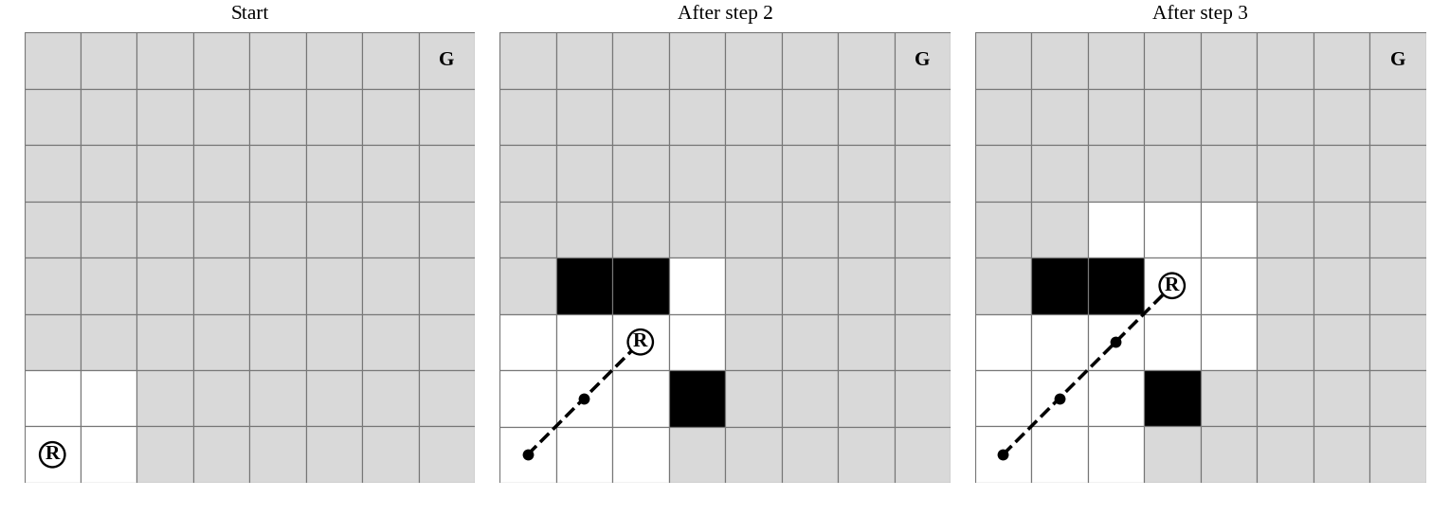
Figure 3.2: The known region (white) grows as the rover (R) moves; black cells are detected hazards and grey cells are still unknown
The figure shows how this works. At the start nearly everything is unknown. After two steps the rover has discovered a hazard to its left and a rock ahead, and after three steps it has enough information to choose a path around them. The map keeps growing like this until the goal is reached. If the rover finds out that a cell it assumed to be free is a hazard, it simply updates the map and replans, so the model is always corrected by experience.
3.4 Comparison of Online Search with Uninformed and Informed Search
Aspect | Uninformed (BFS, DFS, UCS) | Informed (Greedy, A*) | Online search (LRTA*, online DFS)
Needs full map | Yes, to expand states | Yes | No, learns map while moving
Uses heuristic | No | Yes | Yes, and improves it by learning
Can undo exploration | Assumes states can be re-generated freely | Same | Must physically move, so backtracking costs real energy
Expands nodes | Anywhere in the tree (in memory) | Best node anywhere in memory | Only the local neighbours of the current position
Handles surprises | No, must restart | No, must restart | Yes
Optimality | BFS/UCS optimal | A* optimal with admissible h | Not guaranteed, measured by competitive ratio
Suitability for Mars rover | Poor | Poor without a map | Best

Table 3.2: Comparison of search strategies
An important difference is that offline algorithms can "jump" to any node in their frontier, because the nodes only exist in the computer. A real robot cannot jump. It can only expand the node it is standing at, so online algorithms such as online depth-first search (which backtracks to the last unexplored place) and LRTA\* (learning real-time A*) are designed to work locally. LRTA* stores an estimate H(s) for every visited state, moves to the neighbour with the lowest cost-plus-estimate, and updates H(s) from what it learnt. Over repeated visits the estimates become more accurate, so the rover avoids loops and learns the terrain.
3.5 Most Suitable Approach
The best approach for the rover is an online, heuristic-guided search that keeps a map and replans after every observation, in practice a combination of an LRTA*-style or D* Lite-style planner with a safety layer. The justification follows.
- Uncertainty: the agent does not need the full map. It starts with optimistic assumptions about unknown cells and corrects them as soon as sensors report the truth, so incomplete or noisy information does not stop the mission.
- Adaptability: the sense–update–plan–act loop re-evaluates the situation after every move, so dust storms, shifting soil or newly found hazards are handled immediately. The heuristic (straight-line distance to the sample site) keeps the exploration directed instead of random.
- Safety: the planner treats cells near craters and rocks as high-cost or forbidden and keeps a safety margin around them. It only moves to cells that the sensors have confirmed as safe, and it keeps a return path to a known safe position, so the rover is never forced into an irreversible situation. Battery level and communication windows are included in the cost so that the rover never goes beyond the point of return.
- Efficiency: since only local computation is needed at each step, the algorithm runs on the limited onboard processor, and the stored map can be shared with Earth to improve later missions.
In conclusion, offline and classical informed search methods are not suitable by themselves because they assume a complete known map. An online search agent that learns its environment, updates its internal model continuously and always puts safety first is the most appropriate solution for the Mars rover.
Question 4: Exam Timetable Generation (Constraint Satisfaction Problem)
4.1 Formulating the Problem as a CSP
A constraint satisfaction problem (CSP) is defined by three things: a set of variables, a domain of possible values for each variable, and a set of constraints that restrict the combinations of values. The solution is a complete assignment of values to all variables that satisfies every constraint. Making an exam timetable fits this model very well, because we have to assign a time and a place to each exam such that a set of rules is not broken. Unlike an ordinary search, the path to the solution does not matter, only the final assignment does.
4.2 Variables, Domains and Constraints
Variables
For every course (exam) Ci there is a variable. To make the formulation more detailed, each exam is given two variables: Time(Ci), the exam slot, and Hall(Ci), the hall in which it is held. If there are 40 courses, there are 80 variables.
Domains
- Time(Ci) takes a value from the set of exam slots, for example 10 days with 2 sessions per day, which gives 20 slots: {D1-FN, D1-AN, D2-FN, ...}.
- Hall(Ci) takes a value from the set of available halls {H1, H2, ..., Hk}.
- Domains can be reduced at the start. For example if a faculty member is unavailable on day 3, the slots of day 3 are removed from the domain of the courses that this faculty member invigilates.
Constraints
No. | Requirement in the problem | Type | Constraint written formally
1 | No student should have overlapping exams | Binary | If courses Ci and Cj have a common student, Time(Ci) ≠ Time(Cj)
2 | Limited number of exam halls | Global (capacity) | For each slot t, the number of exams in t is not more than the number of halls, and the students in a hall do not exceed its seating capacity
3 | Hall can hold only one exam at a time | Binary | If Time(Ci) = Time(Cj) then Hall(Ci) ≠ Hall(Cj)
4 | Some subjects must be scheduled before others | Binary (precedence) | If Cj needs Ci first, Time(Ci) < Time(Cj)
5 | Faculty availability | Unary | Time(Ci) must belong to the available slots of its faculty; a faculty member cannot invigilate two halls at once
6 | Special accommodations (extra time, ground floor, separate room) | Unary / binary | Hall(Ci) must be in the list of suitable halls; extra-time students need a longer slot, so the next slot in that hall must be free

Table 4.1: Constraints of the exam timetable problem
The constraints are of different kinds. Unary constraints involve one variable (faculty availability). Binary constraints involve two variables (clash of two exams). Global constraints involve many variables at the same time (hall capacity in a slot). There can also be soft constraints, which are preferred but not compulsory, such as avoiding two exams for the same student on consecutive days or avoiding the very early slots. Soft constraints turn the problem into a constraint optimisation problem, where the best solution is the one that violates the fewest preferences.
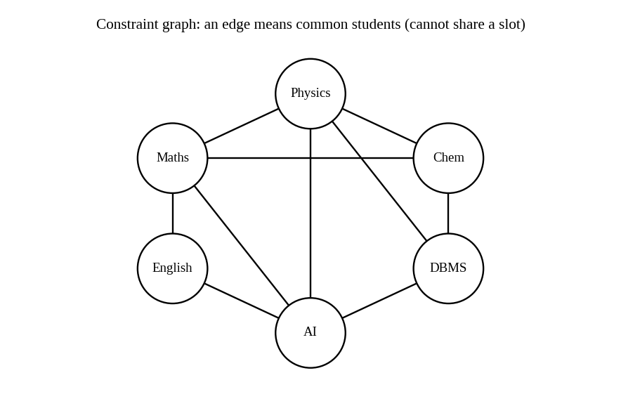
Figure 4.1: Constraint graph for a small example with six courses
The constraint graph shows each course as a node and an edge between two courses that share at least one student. Solving the timetable for the clash constraint is therefore the same as colouring the graph, where each colour is an exam slot and two connected nodes cannot have the same colour. In this small example there is a triangle (Maths, Physics, Chemistry), so at least three different slots are needed.
4.3 Backtracking Search in this Scenario
Backtracking search is a depth-first search that assigns one variable at a time. After each assignment it checks whether the constraints involving the assigned variables are still satisfied. If one is violated, it immediately abandons that choice and goes back (backtracks) to try the next value of the previous variable. It does not generate the whole assignment before checking, which makes it much better than simple generate-and-test.
Step | Action
1 | Choose an unassigned variable, e.g. the Maths exam.
2 | Pick a value from its domain, e.g. Slot 1, and check it against the constraints.
3 | Move to the next variable, e.g. Physics. Slot 1 is rejected because Maths and Physics share students, so try Slot 2.
4 | Continue with Chemistry. If no slot is possible (all conflict with earlier assignments) then backtrack to Physics and try another slot.
5 | Continue until all variables are assigned (success) or the domain of the first variable is exhausted (no solution).

Table 4.2: Steps of backtracking search
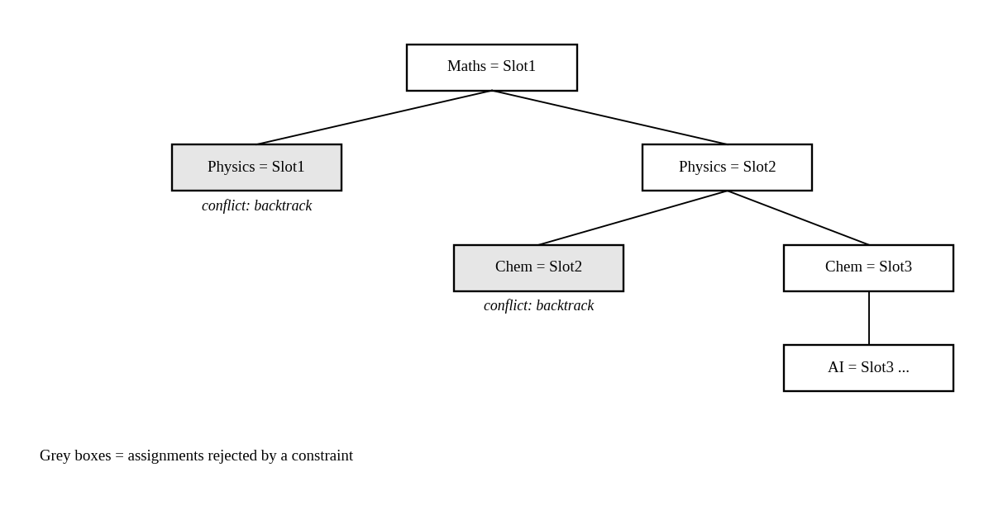
Figure 4.2: A part of the backtracking search tree for the example
Plain backtracking can still be very slow for a real university with hundreds of courses, because it only discovers a failure when it is already in a deep part of the tree and may repeat the same mistake in many branches. This is called thrashing. The speed can be improved by good heuristics for choosing the order of variables and values:
- Minimum Remaining Values (MRV): pick the variable with the fewest legal values left first. A course with only two possible slots should be scheduled before a course with twenty, so that failures are found early.
- Degree heuristic: among ties, pick the course that is involved in the most constraints (for example a first-year common subject that is taken by many students).
- Least Constraining Value: try first the slot that removes the fewest options from the neighbouring courses.
4.4 Constraint Propagation and Forward Checking
Constraint propagation means using the constraints to reduce the domains of the variables before and during the search, so that impossible values are removed early. In forward checking, whenever a value is assigned to a variable X, every unassigned variable Y that is connected to X by a constraint has the inconsistent values removed from its domain. If the domain of any variable becomes empty, the search backtracks immediately, without waiting to reach that variable.
Course | Initial domain | After Maths = Slot 1 | After Physics = Slot 2
Physics | {1, 2, 3} | {2, 3} | assigned
Chemistry | {1, 2, 3} | {2, 3} | {3}
AI | {1, 2, 3} | {2, 3} | {3}
English | {1, 2, 3} | {2, 3} | {2, 3}
DBMS | {1, 2, 3} | {1, 2, 3} | {1, 3}

Table 4.3: Domains shrinking under forward checking (using the graph in Figure 4.1)
In the table, after Maths is placed in Slot 1, forward checking removes Slot 1 from the domains of Physics, Chemistry, AI and English, since they share students with Maths. After Physics is placed in Slot 2, Slot 2 is removed from Chemistry and AI, and the algorithm now knows that both of them must use Slot 3. Since Chemistry and AI are not neighbours in the graph, this is fine. If instead there were an edge between them, an empty domain would appear at once and the search would backtrack at this point, saving all the work below.
Forward checking only looks at the neighbours of the last assigned variable. A stronger method is arc consistency (AC-3), which keeps checking pairs of variables until every value in every domain has a supporting value in its neighbour's domain. It costs more work per step, but it detects failures that forward checking misses, and it is very effective on timetable problems that have many precedence constraints. A balanced approach is to use full AC-3 once at the start and forward checking (or maintaining arc consistency) during the search.
4.5 Real-World Challenges and the Best Strategy for Scalability
Challenges
- Size: thousands of students, hundreds of exams and many halls give an enormous search space, and CSP is NP-complete in general, so no efficient exact algorithm is known for the worst case.
- Conflicting and changing requirements: a faculty member falls ill, a hall is under repair, or a late registration is received. The timetable must be repaired without redoing everything.
- Over-constrained instances: sometimes no complete solution exists that satisfies all rules. The system must then relax soft constraints and clearly report which rules were broken.
- Fairness and preferences: students prefer gaps between exams, and the university wants to reduce the number of invigilators and halls used.
- Special accommodations: these create many unary constraints and reduce the domains strongly, so they should be handled first.
Recommended strategy
No single technique is enough, so I recommend a combination:
- Model carefully and reduce the domains first (node consistency and AC-3), which removes many impossible values before search starts.
- Backtracking with MRV, degree heuristic and forward checking (or MAC) to find a feasible timetable satisfying all hard constraints.
- Handle the hardest items first: schedule the exams with special accommodations, precedence chains and large enrolment before the easy ones.
- Decompose the problem: divide it by department or by day (tree-structured or cluster decomposition), solve each part, and then combine.
- Use local search (min-conflicts) for repair and improvement: after a first complete timetable is available, the min-conflicts heuristic picks a conflicting exam and moves it to the slot that causes the fewest conflicts. This is very effective for last-minute changes, because only a few exams move.
- Treat soft constraints as an optimisation step with a penalty score, using simulated annealing or a genetic algorithm if more quality is wanted.
This strategy scales because the expensive exact search is used only to find a valid base timetable, with strong pruning from constraint propagation, and the cheap local repair methods handle the frequent small changes. It is also easy for the administration to understand, because every rule in the university can be written as a constraint and checked automatically.
Question 5: Strategic Game AI (Minimax and Alpha-Beta Pruning)
5.1 How Minimax Models the Problem
The real-time strategy game is a two-player, competitive game. The AI wants to win, and the human player wants the AI to lose, so whatever is good for one is bad for the other. Such a game is called a zero-sum game, and the natural way of modelling it is the Minimax algorithm. The game is represented as a tree.
Game element | Representation
State (node) | A complete snapshot of the game: positions of all units, resources, buildings, map control, and whose turn it is
Actions (edges) | The legal moves: move a unit, attack, build, gather resources, research
MAX player | The AI, which tries to choose moves that maximise the score
MIN player | The human opponent, assumed to choose moves that minimise the AI's score
Terminal test | A state where one side has won, lost or the game has drawn, or the search depth limit is reached
Utility | A number showing how good the state is for the AI (+ for winning positions, − for losing ones)

Table 5.1: Mapping of the game to a Minimax tree
The algorithm works from the leaves to the root. At a leaf the utility is known. At a MAX node (the AI's turn) the value is the maximum of the values of its children, because the AI will pick its best move. At a MIN node (the human's turn) the value is the minimum of the children, because the AI assumes that the opponent will play the move that is worst for it. These values are passed up until the root, and the AI plays the move that leads to the child with the highest value. The key idea is that the AI chooses assuming the opponent plays optimally, so it is guaranteed a result at least as good as the value computed, whatever the human does.
5.2 Computational Challenges of Large Game Trees
The main problem is the size of the tree. If every state has on average b legal moves and the search looks d moves ahead, then Minimax must examine about b to the power d positions, so the time grows exponentially, O(b^d), while the memory with depth-first implementation is O(b·d). In chess b is about 35, and in a real-time strategy game it is far bigger, because the player can command many units at the same time, so the number of combined actions in a single turn can be in thousands or more. For example, with b = 10 and d = 8 the tree already has about 100 million nodes, and with b = 35 and d = 10 it has about 2.7 x 10^15 nodes.
- Time limit: the decisions have to be made in a fraction of a second, but the tree is far too big to search to the end of the game.
- Real-time nature: in an RTS the state changes continuously while the AI thinks, so a long computation becomes out of date.
- Imperfect information: the fog of war hides the opponent's units, so the exact state is not known.
- Evaluation cost: each evaluation of a complex state is itself expensive.
- Horizon effect: if the search is cut at a fixed depth, a disaster that happens just after the limit is not seen, so the AI may make a move that postpones a loss instead of avoiding it.
5.3 How Alpha-Beta Pruning Improves Efficiency
Alpha-beta pruning gives exactly the same decision as Minimax, but it avoids searching the parts of the tree that cannot influence the final decision. It keeps two values while searching:
- Alpha (α): the best value that MAX can already guarantee on the path to the current node (the highest value found so far for MAX).
- Beta (β): the best value that MIN can already guarantee on the path to the current node (the lowest value found so far for MIN).
The initial values are α = −∞ and β = +∞. Whenever α ≥ β at a node, the remaining children of that node are pruned (not examined), since a rational opponent or the AI itself would never allow the game to reach that node.
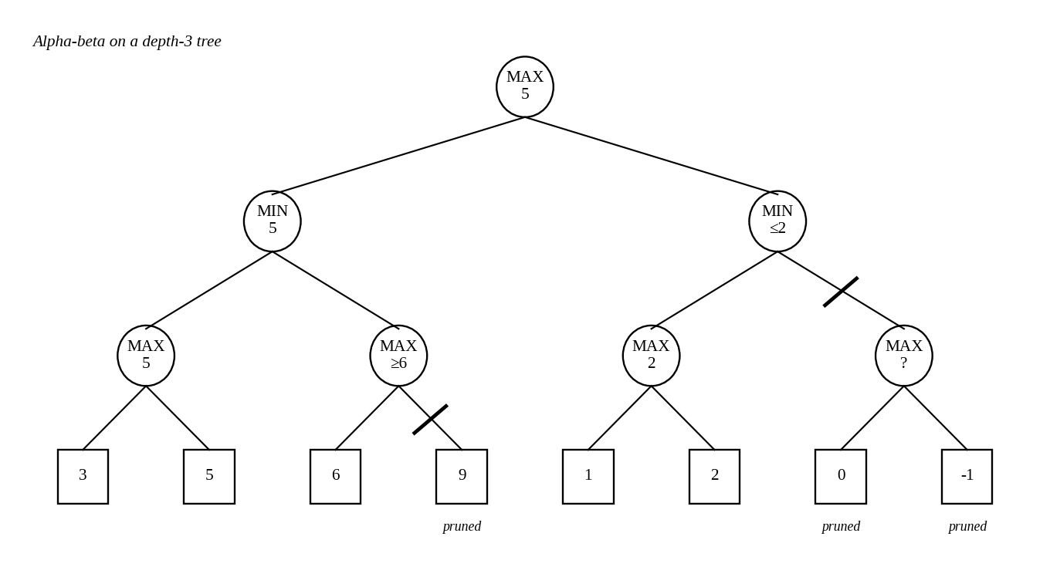
Figure 5.1: Alpha-beta pruning on a small tree (the slash marks a cut-off)
Reasoning for the example in Figure 5.1
- The search goes down the left side first. The left MAX node has leaves 3 and 5, so its value is 5. The left MIN node therefore has β = 5 at this point (it can get at most 5).
- In the next MAX node under the left MIN node, the first leaf is 6. This MAX node will give at least 6, but the MIN parent already has an option worth 5 and would never choose a value of 6 or more. Since 6 ≥ β = 5, the second leaf (9) is pruned.
- The left MIN node finishes with the value 5, so the root now has α = 5, meaning that the AI can already guarantee at least 5.
- On the right side, the first MAX node has leaves 1 and 2, giving 2. The right MIN node is now worth at most 2. Since 2 is less than α = 5, the AI will never choose this branch, so the other child of the right MIN node (with leaves 0 and −1) is pruned entirely.
- The final value at the root is 5, which is the same as plain Minimax would give. Three leaves out of eight (9, 0 and −1) were not examined.
The amount of saving depends on the order in which moves are examined. In the worst case (the worst move is always tried first) nothing can be pruned and the algorithm takes O(b^d) time, like Minimax. In the best case, when the best moves are examined first, the time reduces to about O(b^(d/2)). This means that for the same time the search can go twice as deep, which is a very large improvement in playing strength. With random ordering the complexity is about O(b^(3d/4)).
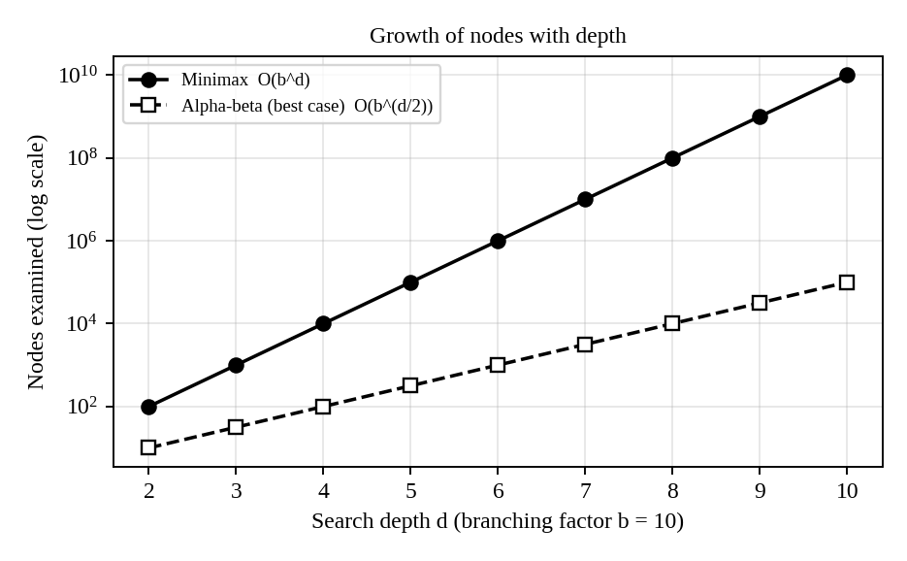
Figure 5.2: Best-case saving obtained by alpha-beta pruning
To get closer to the best case, move ordering is used. The moves that look strongest, such as captures or attacks on the opponent's main base, are tried first. Other helpers include killer moves (moves that caused a cut-off at the same level before), the history heuristic, and iterative deepening, in which a shallow search is done first and its results are used to order the moves for the deeper search. Iterative deepening also provides a good answer whenever the time is over, which is useful in real-time games.
5.4 Designing the Evaluation Function
Since the AI cannot search to the end of the game, it must stop at a certain depth and estimate how good the position is. This estimate is the evaluation function. It should be quick to compute and should correlate with the real chance of winning. A common design is a weighted linear sum of features:
Eval(s) = w1·f1(s) + w2·f2(s) + w3·f3(s) + ... + wn·fn(s)
Feature | What it measures | Reason for including it | Weight (sample)
f1 Army strength | Number and quality of own units minus opponent units, weighted by unit type | Stronger army usually means winning battles | 5
f2 Resources | Stock of gold/wood and rate of collection | Resources decide how fast the army and buildings can grow | 3
f3 Base and tech level | Number of buildings, upgrades, technology reached | Shows long-term potential | 2
f4 Map control | Share of the map and key points controlled, vision | Gives safe income and information | 2
f5 Unit safety / position | Units in a good position (high ground, grouped), exposed units | Avoids careless losses | 1.5
f6 Threat and defence | Enemy units near own base versus own defences | Detects danger of immediate loss | 4
f7 Win / loss | Large +/− value if the main base is destroyed | Terminal condition | ±1000

Table 5.2: Features of the evaluation function
- Speed: every feature is a simple count or sum, so thousands of positions can be evaluated per second.
- Balance of short-term and long-term: army and threat terms respond to immediate fights, resources and tech terms respond to the long-term plan.
- Weights: they can be set by expert knowledge at first and then tuned by playing many games (self-play) or by machine learning, so the function improves over time.
5.5 Balancing Optimality and Real-Time Performance
Perfect play requires searching the whole tree, which is not possible, so the AI must accept a good decision instead of the perfect one. The strategy I recommend is a combination of the following techniques:
Technique | How it helps
Depth-limited alpha-beta with the evaluation function | Cuts the tree at a depth that fits the time limit while keeping Minimax's decision quality
Iterative deepening with a time check | Searches depth 1, 2, 3, ... and returns the result of the deepest completed search when the time is over, so there is always a usable move
Good move ordering, killer moves, transposition table | Increases the amount of pruning and avoids searching the same position twice
Reduced branching (abstraction) | Groups units into squads and considers only a few high-level commands such as "attack", "expand", "defend", instead of every unit action
Selective deepening / forward pruning | Searches deeper on forcing lines (attacks) and shallower on quiet moves
Opening book and scripts | Uses stored moves for the early game, where the best actions are well known, saving time for the middle game
Time management | Gives more time to critical positions and less to obvious moves

Table 5.3: Recommended combination of techniques
To summarise, the AI should use depth-limited, iteratively deepened alpha-beta search with strong move ordering and a well-designed evaluation function, applied on an abstracted version of the game, with a firm time limit per decision. In this way the optimality is almost fully kept for the part of the tree that is searched, because alpha-beta never changes the Minimax result, and the response time stays within the real-time limit, because the search is stopped by the clock and not by completion. If more strength is required later, Monte Carlo Tree Search can be used as an alternative for the largest branching situations.

